Title of the contribution
A.B. First author¹, C. Other author², D.E. Additional authors (from same institution)²
1. Name of Institution/Department, City, Country, Email address
2. Name of Institution/Department, City, Country, Email address
ABSTRACT: this short summary should be 5 to 10 lines long.
2
Keywords: Please use Times New Roman, font: 10 pt.; separated by semicolon; Maximum 6

Introduction, Context, Motivation
All papers must be written in English. The contribution should not exceed 10 pages. It content and the standard of the written English. Authors that require assistance in English should seek professional language service by themselves. Papers with significant deficiencies in technical content and/or English will be declined. The organizing committee also reserves is the author’s responsibility to ensure the quality of the technical the right to return papers that do not fully comply with the format instruction given in this template. The file name should report the surname of the first author followed by the acronym of the meeting (e.g., Rossi_EWG_IE.docx; Rossi_EWG_OOE.docx). Paper submissions must include electronic versions in a Microsoft Word document (MS-docx) and an Adobe Acrobat Portable Document Format (PDF).

equations
A sample of equation is given below and each equation should be numbered consecutively, refer to equations by these numbers. Equations should be written using the equation editor of Word and the font size 10 pt. The layout should be standard "professional". All symbols should be in italics.
The used parameters must be described below the equations, and units should be given in parentheses, as follows:

$e^{z}=q^{'}∙K_{q}^{z}+c∙K_{c}^{z}$ (1)

where e^{z} (kPa) is the earth pressure at depth z (m), etc.

tables and figures
Table headers should be in bold. The reference to figures and tables should be as Figure 1 and Table 1, respectively. Figures and tables should be numbered consecutively. Please add a line after tables and figures, except before a section title.
Table 1. Sample (use 10 pt both in headers and in text).
Header | Sub 1.1 | Sub 1.2
Sub 2.1 | 1 | 4
Sub 2.1 | 2 | 5
Sub 2.1 | 3 | 5

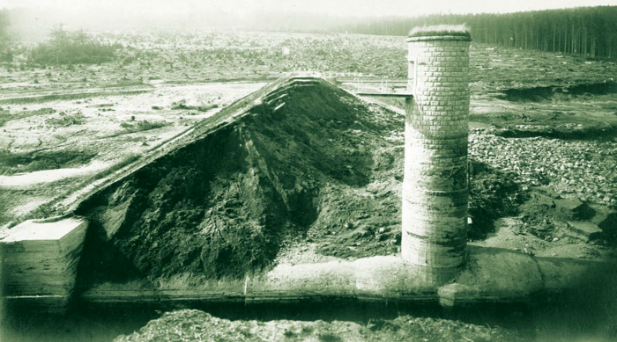  Figure 1. The breached dam Bílá Desná, September 1916. | 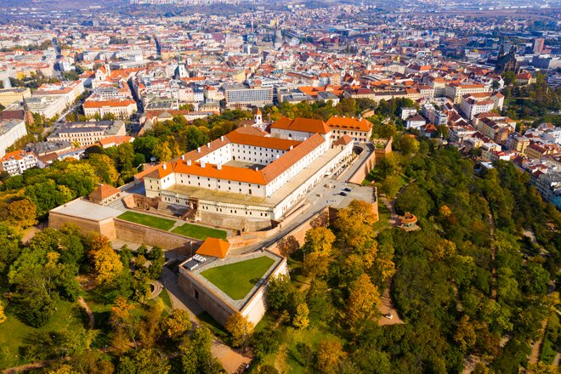  Figure 2. Špilberk castle, Brno.

References format
The list of references should be arranged in alphabetical order, using Times New Roman, 10pt size, hanging of 0.5 cm. Please cite references in the text using the author’s last name and date of publication, e.g., (Jenkins, 1980), (Jenkins and Smith, 1980), or (Jenkins et al., 1980). References should be given with precise data to help the reader finding them, including volume and page numbers. Authors are invited to provide DOI numbers when available. The link on the DOI should be clickable (for example, http://doi.org/[DOI]). Below examples are given for each reference type format.

Acknowledgments

References
Bermingham, P. and Janes, M.C. (1989). An innovative approach to load testing of high capacity piles. Proceedings of the International Conference on Piling and Deep Foundations, J. B. Burland and J. M. Mitchell (eds.), Balkeman, Vol. 1, pp. 409-413.

